**Games and Puzzles**

**for Brain Health and Dementia Care**

*(This list has been prepared by Lucas County Board of DD Senior Supports Committee as part of our Senior resources web page.)*

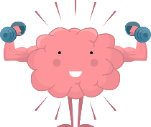

**Brain-Building Resources**

**BrainHQ**

BrainHQ is your online headquarters for working out your brain. Think of it as a personal gym, where you exercise your memory, attention, brain speed, people skills, intelligence and navigation instead of your abs, delts, or quads. Just as our bodies require care and exercise over the course of life, so do our brains. BrainHQ provides the exercise your brain needs to be at its sharpest. A 30-day trial is free, then subscriptions range from $8 to $14 per month

**For full site click the link:** <https://www.brainhq.com/?utm_source=google&utm_medium=cpc&utm_campaign=brand&utm_content=9892976841%2B431881898347&utm_term=cognitive%20games&gad_source=1&gclid=Cj0KCQiAgqGrBhDtARIsAM5s0_mEbS50S5hO7hchnhK9tdNzivFoWKipQXpQseVfBI4qpvk0dH5KWccaAhJyEALw_wcB&v4=true&fr=y>

**Lumosity**

[Lumosity](https://www.lumosity.com/en/) is a popular online brain training platform that offers a variety of games that test your memory, concentration, problem-solving skills, and more. With the free version (no purchase required), you can play three brain games a day. You can upgrade to a paid subscription for more. 

**For full site Click Link**: **<https://www.lumosity.com/en/>**

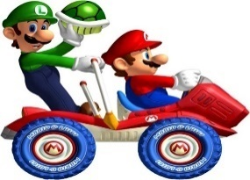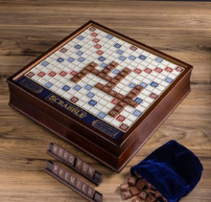**7 of the BEST ADULT BRAIN-BUILDING PUZZLES** 1. Sudoku 2. Scrabble or Crossword Puzzles 3. Lumosity4. Chess 5. Jigsaw Puzzles 6. Matching Card Games 7. Mario Kart

**For full site Click Link**:

[**https://www.completingthepuzzle.com/blog/7-best-brain-games-for-adults**](https://www.completingthepuzzle.com/blog/7-best-brain-games-for-adults)

**Puzzles (some of these are free, some require a subscription)**

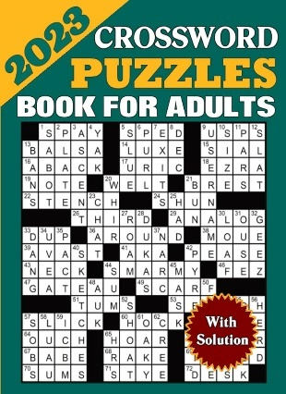

<https://www.npr.org/series/4473090/sunday-puzzle>

<https://gamesmagazine-online.com/category/puzzles/>

<https://www.hos.com/home>

<https://www.wgte.org/radio/local-radio-programs/jazz-spectrum>

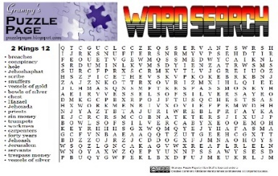**Word Search**

<https://thewordsearch.com/>

**OTHER GAMES**

***Mah-jongg (Mahjong)***

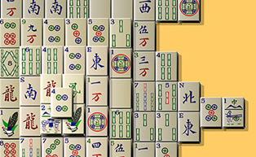

Mah-jongg offers cognitive, social, physical and mental, benefits for seniors, as well as stress relief. Yoshiro Katsuura, an orthopedic spine surgeon and author of *The Spine Encyclopedia*, who treats many older patients, says, “The ability to quickly solve and respond to different problems deteriorates as people grow older. Participating in games of strategy like mah-jongg can be protective against this decline. Meaningful, intellectually stimulating social engagement prevents the depression of isolation.”

Read more at [AARPethel.com](https://www.aarpethel.com/lifestyle/the-many-benefits-of-playing-mah-jongg#:~:text=According%20to%20an%20October%202021,Encyclopedia%2C%20treats%20many%20older%20patients) and [dovemed.com](https://www.dovemed.com/healthy-living/wellness-center/health-benefits-mahjong)

[Play mah-jongg online free here](https://games.aarp.org/category/mahjongg).



***OuiSi (Pronounced "We-See")***

Includes Original, Nature, and Getty Museum versions

<https://shop.ouisi.co/pages/memory-care>

Intuitive visual games designed to stimulate and captivate individuals with AND without dementia, foster a low-stress environment, and encourage understanding and creativity while bridging generations and sparking meaningful conversations (with or without words).

***Qwirkle*** (somewhat like Dominoes or Rummy)

<https://www.ultraboardgames.com/qwirkle/qwirkle-rummy.php>

<https://alzheimersactivities.wordpress.com/2014/05/28/play-qwirkle/>

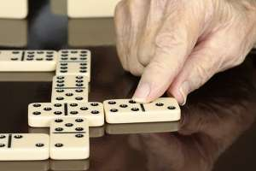

***Dominoes*** are another game considered beneficial for people with dementia or Alzheimer’s because they have a familiar design and are easy to hold and maneuver, and because a variety of games can be played using them, depending on the stage of dementia. It is especially helpful when the emphasis is on playing the game, not scoring, winning, or losing. See this [carewell.com post](https://www.carewell.com/resources/blog/games-for-adults-with-alzheimers-or-dementia/).

[List of different games that use Dominoes](https://en.wikipedia.org/wiki/List_of_domino_games).

To find Dominoes and other Alzheimer’s products

https://best-alzheimers-products.com/product-category/activities-for-alzheimers/games-for-alzheimers-dementia

**All About Us**

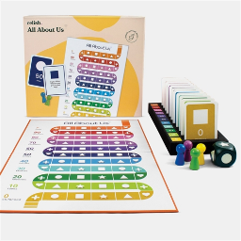

This is a cooperative, life-story-telling board game in which all players share their stories and explore their lives with each other.

Benefits for those with dementia include:

* Helping them connect with, and recall, positive memories
* Sparking conversations and promoting quality time with family, friends and caregivers across all generations – reducing loneliness
* Bosting morale and self-esteem because the other players show interest in the opinions and experiences of that person

[Learn more at this link.](https://www.alzstore.com/memory-activity-game-for-dementia-p/h014.htm)

***Pinball***

Pinball can benefit those with dementia!

Click here to read about what the benefits are, as well as where to play pinball in the Toledo area.

Click here for some pinball history.

***Jeopardy! Trivia Games***

<https://www.jeopardy.com/games-more>