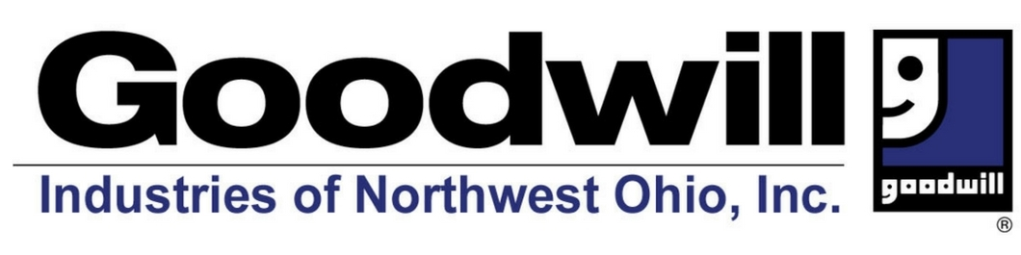

Spring clean-up can help individuals served by the Lucas County Board of DD!

FRIDAY AND SATURDAY, MAY 20-21, 2022 DURING GOODWILL’S NORMAL BUSINESS HOURS

All you have to do is clean out those closets and drop off your gently used items to any Goodwill donation drop off site listed below. Cut off the bottom and attach to your item/items and tell them that you are donating on behalf of LCBDD and the FANS NETWORK! Your donations help get Goodwill Vouchers into the hands of individuals in need of clothing and household items.

Goodwill Stores at the following locations: Donation Stations at the following locations:
2021 S Reynolds Rd, Toledo, Ohio 43614 3022 Glendale Ave, Toledo, Ohio 43614 2600 W Sylvania Ave, Sylvania, Ohio 43613 7634 W Sylvania Ave, Sylvania, 43560
3550 Executive Pkwy Toledo, Ohio 43606 5810 Monroe St, Sylvania, 43560
5917 Weckerly Rd, Whitehouse, OH 43571 Hours: Fri & Sat 10am - 6pm
3249 Navarre Ave Oregon, Ohio 43616
Hours: Fri & Sat 10am - 8pm

Goodwill Industries of Northwest Ohio, Inc.’s mission is to help people with disabilities get jobs by providing vital workforce training programs.

---------------------------------------------------------------------------------------------------------------------------------------
Please attach to donated item/items
This was donated on behalf of FANS and the Lucas County Board of DD
