[](https://www.google.com/url?sa=i&rct=j&q=&esrc=s&source=images&cd=&cad=rja&uact=8&ved=0ahUKEwi19fTMio_ZAhVG9YMKHcNjBsgQjRwIBw&url=https://www.picquery.com/c/word-salute_ZVHTNZpeqcntFb|eX9MPg3*nf6llxwS1PyATvdYqNzg/&psig=AOvVaw1lBzE6VWtYQUcNSZV-H_yP&ust=1517930336160258) **Self-Advocates LUcas TolEdo**

Meetings Second Monday Each Month in 2022, 5:30 to 7 pm.

***You may attend either in person or via Zoom***

***Zoom information is emailed out a day or so before the meeting.***

In-person Location:

Training Center (use Door O).

Board of DD Larc Lane Building, 1155 Larc Lane, Toledo, 43614

Doors open at 5 pm. Light snacks provided.

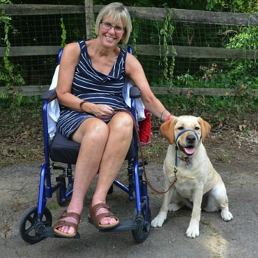

**April Meeting, Monday, April 11**

The guest speaker will be from the Ability Center’s Assistance Dogs program.

*(Photo taken from the “Success Story” page of the program’s web site.)*

[This Photo](http://www.flickr.com/photos/cobalt/3032144418/) by Unknown Author is licensed under [CC BY-SA-NC](https://creativecommons.org/licenses/by-nc-sa/3.0/)

**Masks are now OPTIONAL (although we recommend bringing one) and we no longer check temperatures.**

***But PLEASE make sure you are NOT sick before leaving home. If you don’t feel well, or have any Covid symptoms that day, please stay home!***

To RSVP to attend in person, contact Deetra Mitchell

419-380-5141

[dmitchell@lucasdd.org](mailto:dmitchell@lucasdd.org)

1154 Larc Lane

Toledo, OH 43614

You may bring staff or another support person – tell Deetra about them when you RSVP.

*We take in-person RSVPs until close to the meeting. The Training Center is big, so we can accommodate a lot of people and still social distance.*



SALUTE is…

A self-advocacy group for those served by the Lucas County Board of Developmental Disabilities (DD)